In Java 8, streams and parallel streams are used to process collections of data. While they share a common interface, their underlying execution mechanisms differ significantly.

Streams
A stream in Java 8 operates in a sequential manner. This means that tasks are executed one after another in a single thread.

Key Features of Streams
- Executes sequentially in the invoking thread.
- Suitable for tasks where parallelism is unnecessary or would cause overhead.
Example:
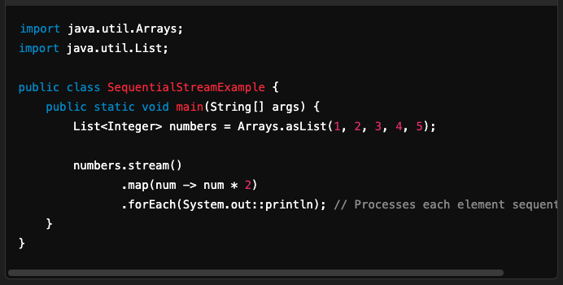

Parallel Streams
A parallel stream divides the data into multiple chunks and processes them in parallel using the Fork/Join Framework introduced in Java 7.

Key Features of Parallel Streams
- Uses multiple threads from the common Fork/Join Pool for parallel execution.
- Automatically manages thread allocation and workload division.
- Useful for CPU-intensive or large-scale data processing tasks.
Example:
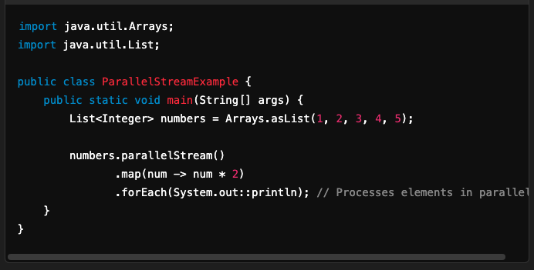

Underlying Mechanism: Fork/Join Framework
The Fork/Join Framework is used to parallelize tasks in parallel streams. Here's how it works:

1. Task Splitting (Forking)
- The framework divides the input data into smaller chunks.
- Each chunk is processed independently by a separate thread in the Fork/Join Pool.

2. Task Joining
- Once all chunks are processed, their results are combined (joined) to produce the final output.

3. Common Fork/Join Pool
- Parallel streams use a shared common Fork/Join Pool by default.
- The size of the pool is determined by the number of available processor cores (Runtime.getRuntime().availableProcessors()).
- You can configure the pool size by setting the java.util.concurrent.ForkJoinPool.common.parallelism system property.

Comparison: Stream vs Parallel Stream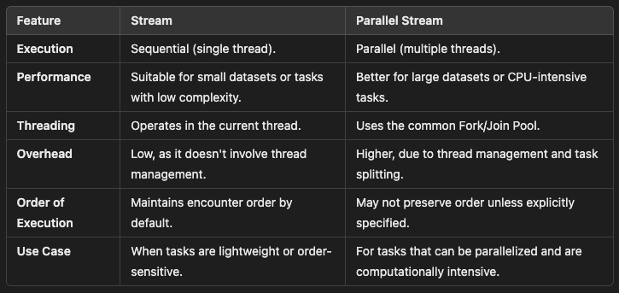

Caveats with Parallel Streams
- Shared Resources:
  - Parallel streams can lead to contention when accessing shared resources (e.g., a shared list or database).
- Overhead:
  - For small datasets, the overhead of splitting tasks and managing threads might outweigh the performance gains.
- Non-Associative Operations:
  - Operations must be stateless and associative to work correctly with parallel streams.
- Thread Pool Limitation:
  - Parallel streams rely on the common Fork/Join Pool. Excessive parallel stream usage may exhaust the pool, leading to degraded performance.

Configuring the Fork/Join Pool
By default, the size of the Fork/Join Pool is based on the number of available CPU cores. You can customize it if needed.

Example: Custom Fork/Join Pool
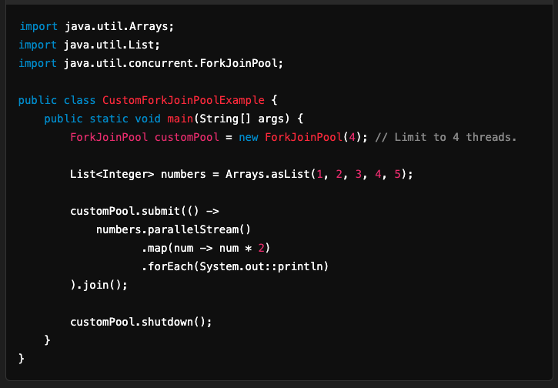

Best Practices
- Use sequential streams for small datasets or when task complexity is low.
- Use parallel streams for:
  - Large datasets.
  - CPU-bound operations.
  - Stateless, non-blocking operations.
- Avoid parallel streams for I/O-bound tasks or when working with a shared mutable state.
Parallel streams can significantly improve performance but require careful consideration of the workload and environment.

